Pipette
# Source: AI Source: Provided by: [Data Path: Persons Table -> ID Column: 1, Name_En Column: Motasem Essam] -> From: [ChatGPT] on [7/17/2026]
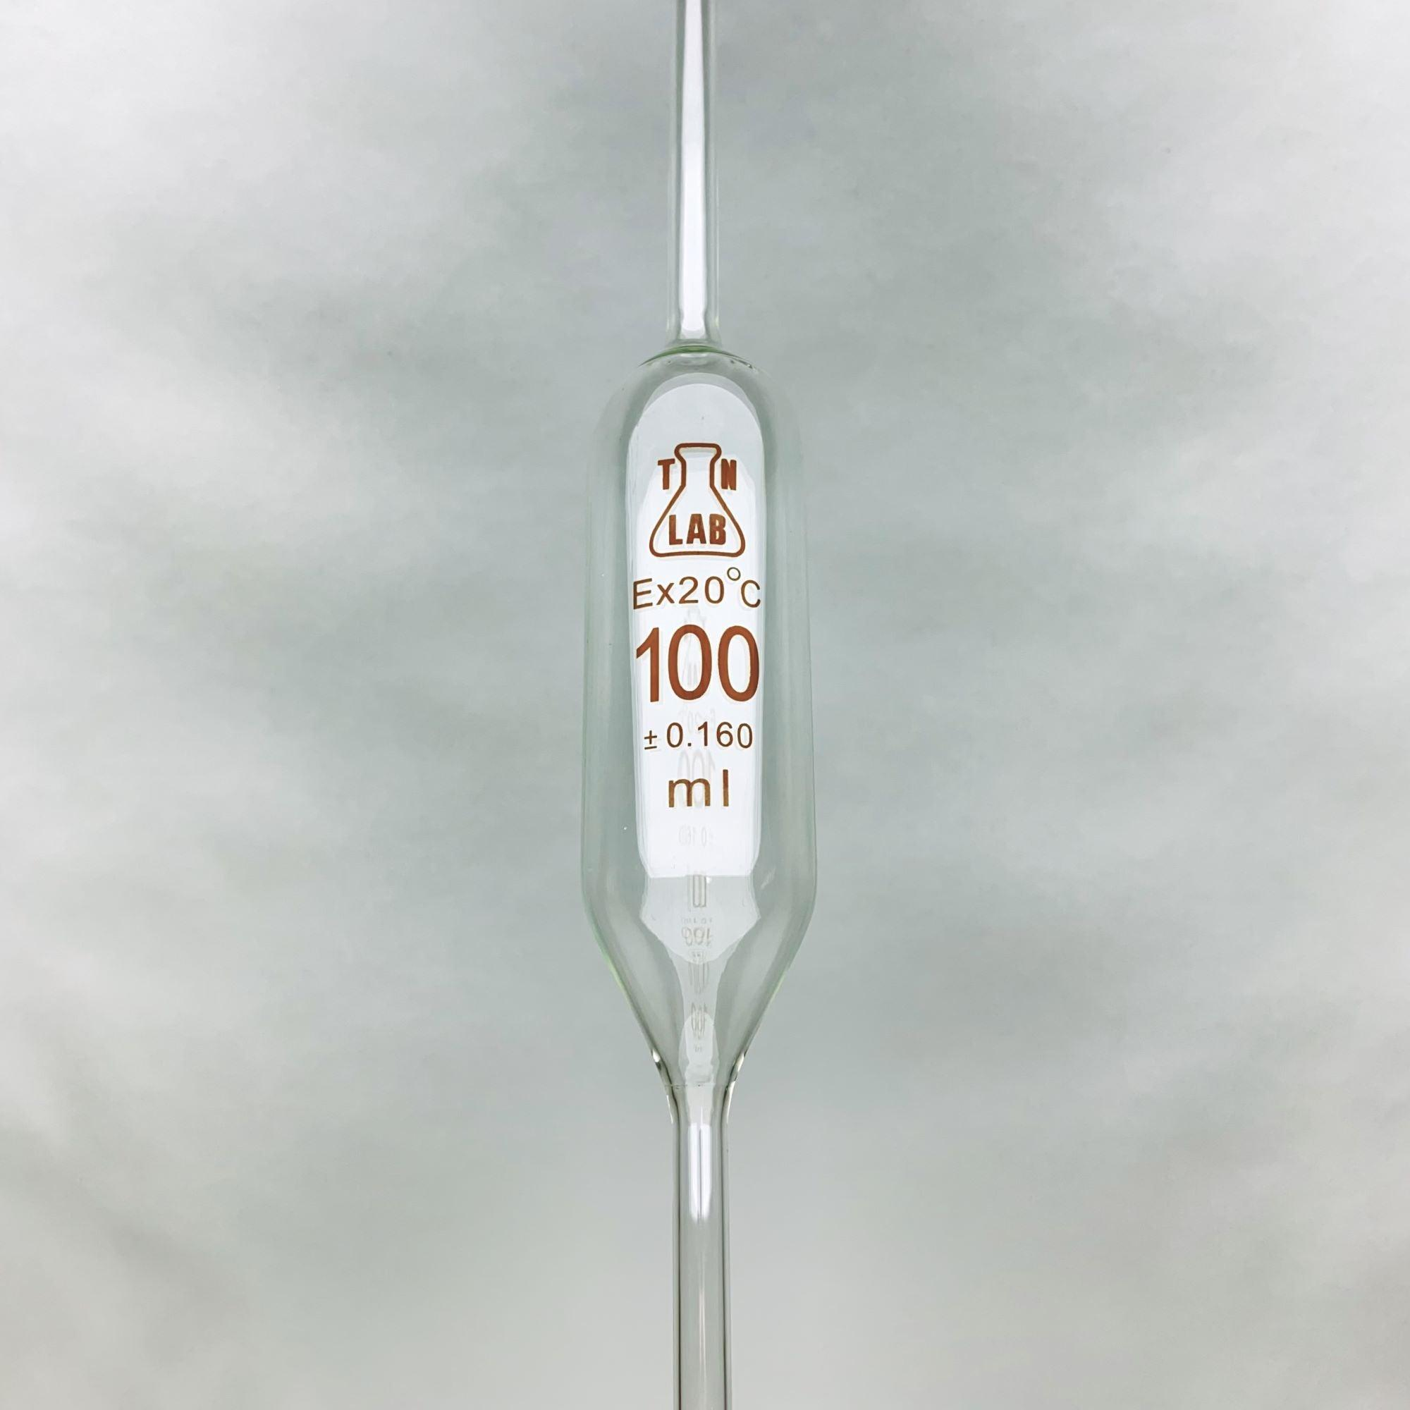
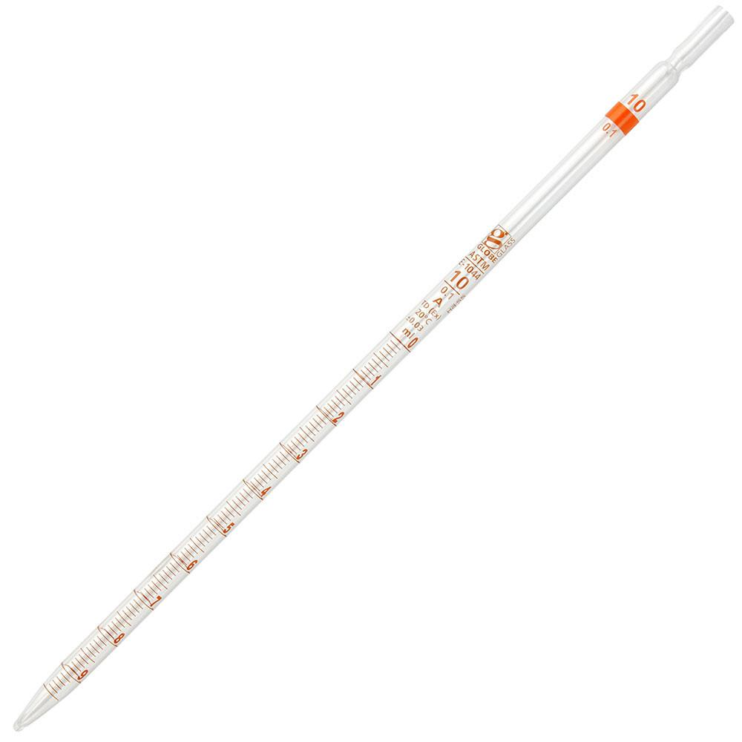
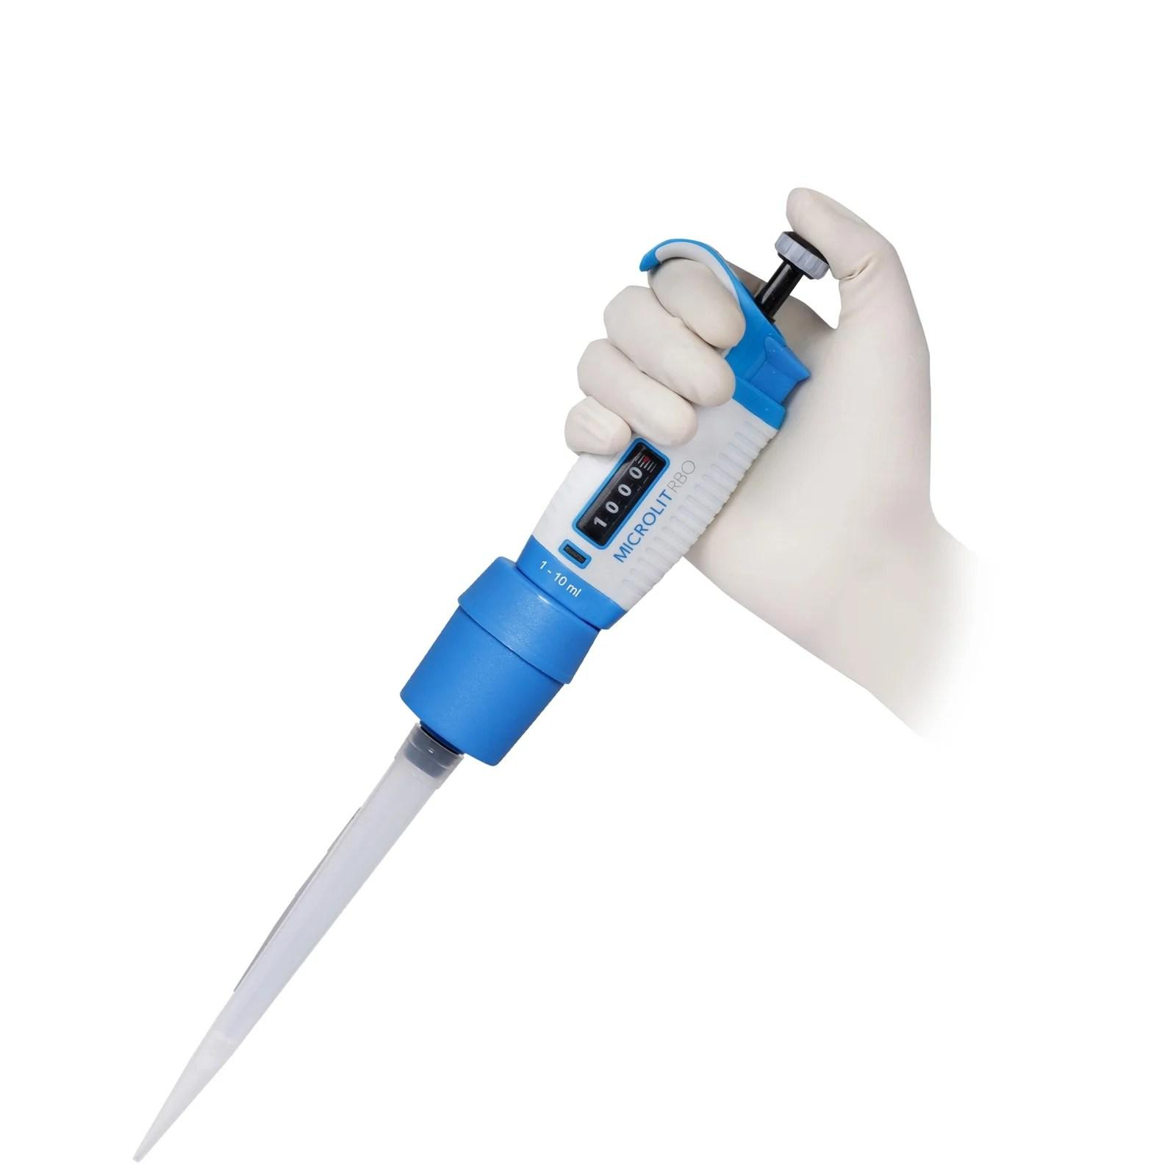
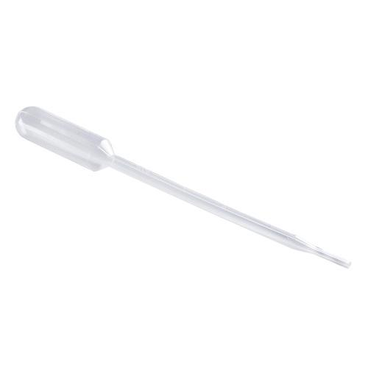
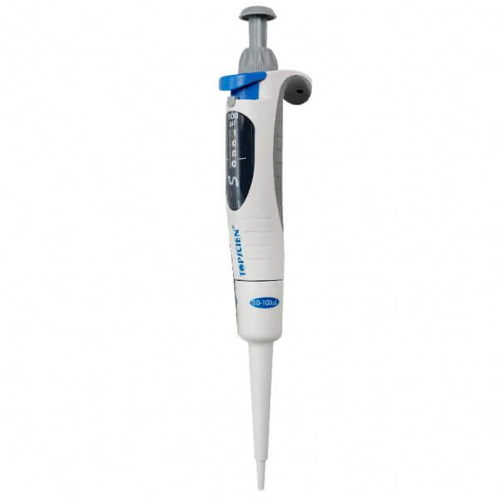
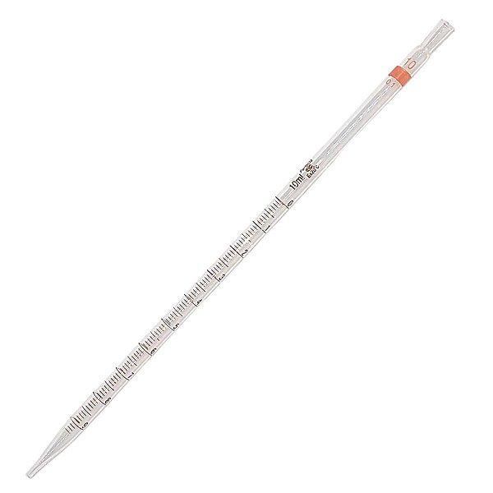
A Pipette is a precision laboratory volume-measuring instrument used to accurately measure, transfer, and dispense small volumes of liquids. Pipettes are essential in chemistry, biology, medicine, microbiology, pharmaceuticals, biotechnology, environmental science, and research laboratories.
Unlike a beaker or graduated cylinder, a pipette is designed for high-accuracy volume measurement.

Definition
# Source: AI Source: Provided by: [Data Path: Persons Table -> ID Column: 1, Name_En Column: Motasem Essam] -> From: [ChatGPT] on [7/17/2026]
A Pipette is a laboratory instrument used to accurately measure and transfer a specific volume of liquid from one container to another.

Purpose
# Source: AI Source: Provided by: [Data Path: Persons Table -> ID Column: 1, Name_En Column: Motasem Essam] -> From: [ChatGPT] on [7/17/2026]
A pipette is used to:
- Measure precise liquid volumes.
- Transfer liquids accurately.
- Prepare laboratory solutions.
- Perform chemical analyses.
- Dispense reagents.
- Conduct biological experiments.
- Handle very small liquid samples.

Principle of Operation
# Source: AI Source: Provided by: [Data Path: Persons Table -> ID Column: 1, Name_En Column: Motasem Essam] -> From: [ChatGPT] on [7/17/2026]
A pipette measures volume by drawing liquid into a calibrated tube or disposable tip and dispensing a controlled amount.
Depending on the type, it operates using:
- Gravity (glass pipettes)
- Air displacement (micropipettes)
- Positive displacement (specialized micropipettes)

Main Components
# Source: AI Source: Provided by: [Data Path: Persons Table -> ID Column: 1, Name_En Column: Motasem Essam] -> From: [ChatGPT] on [7/17/2026]
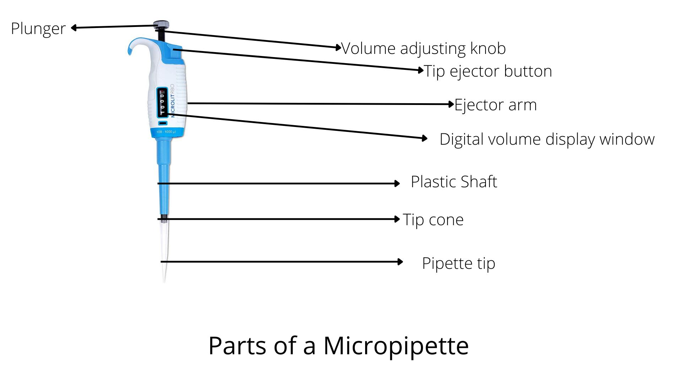
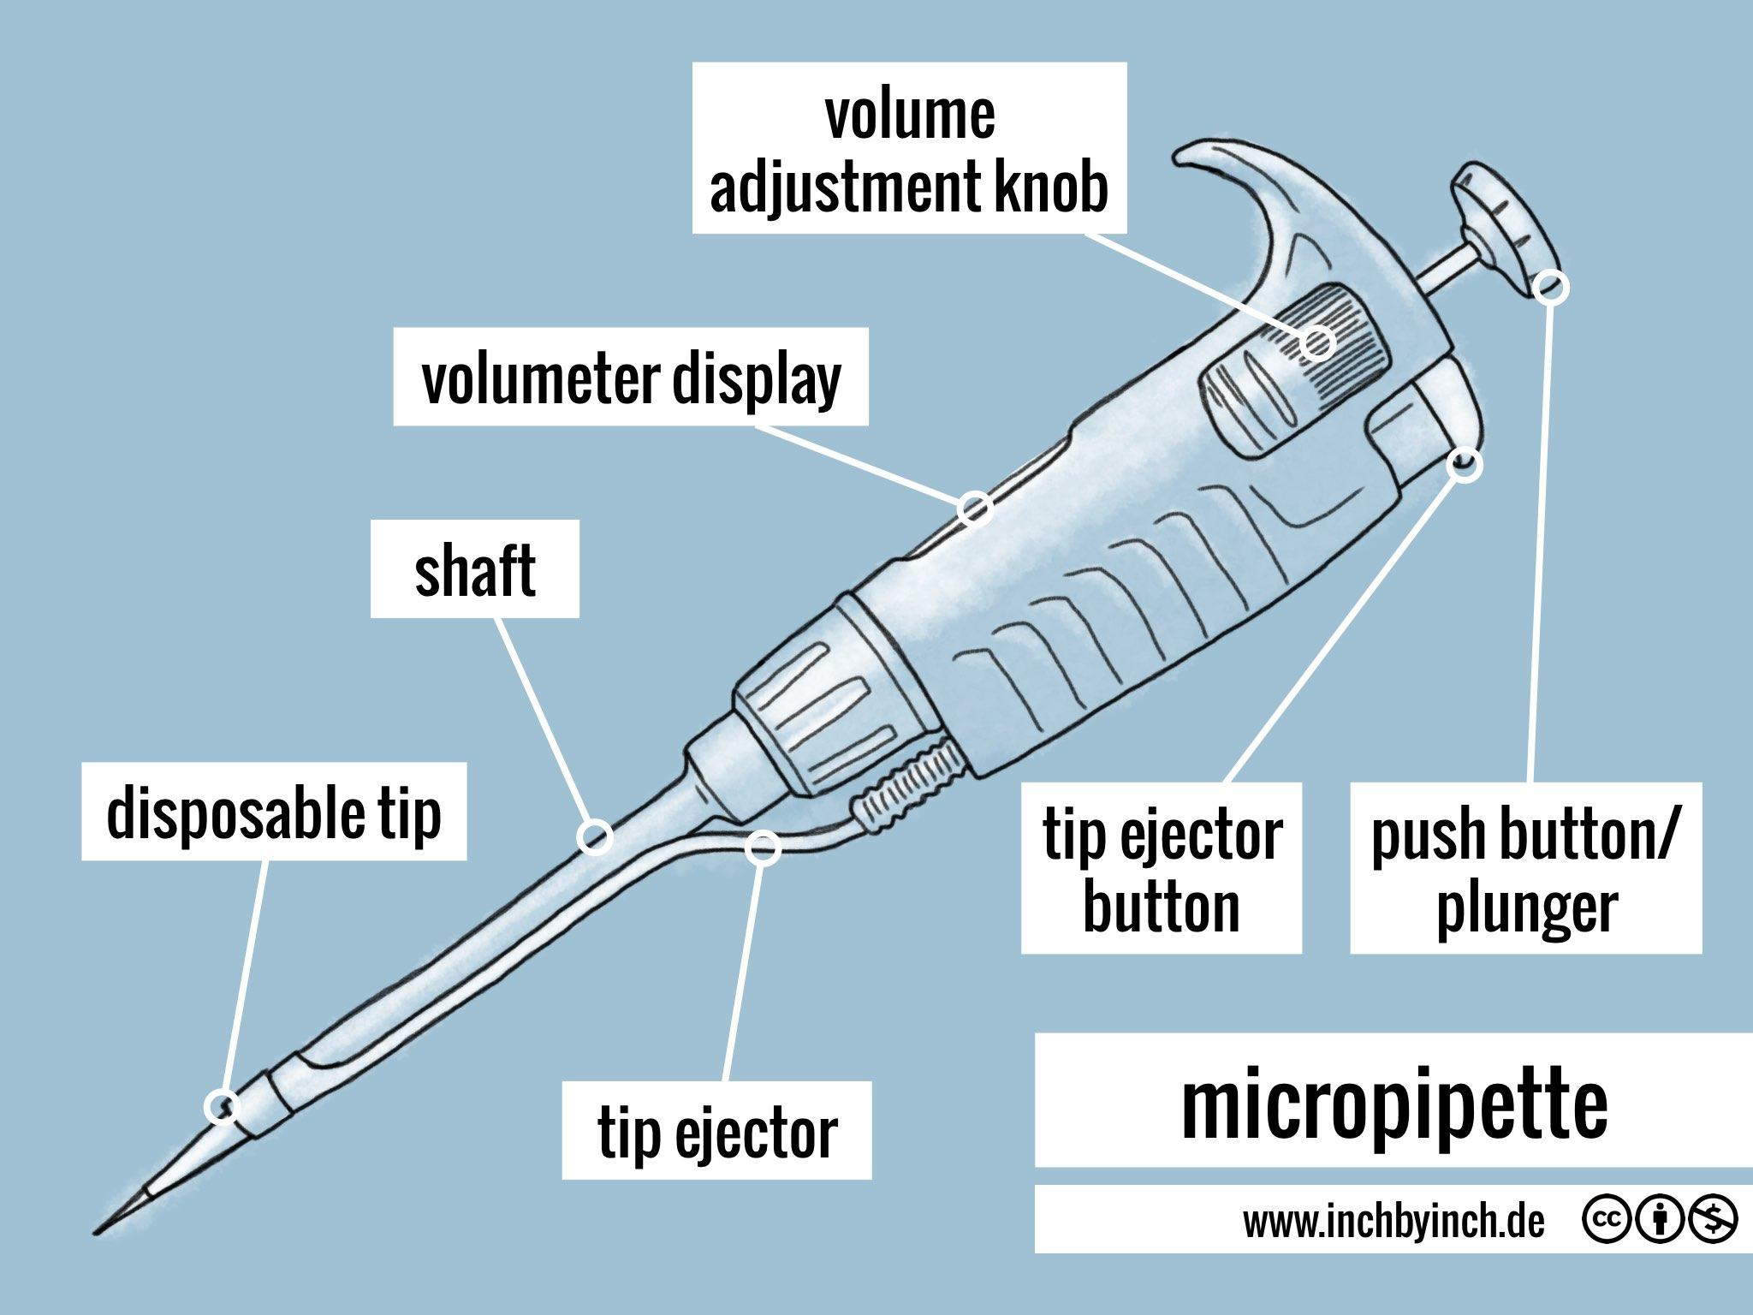
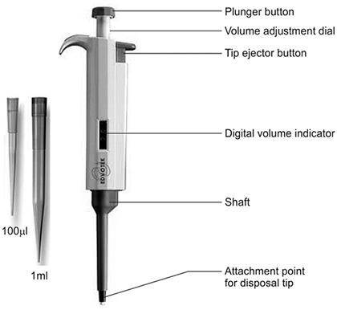
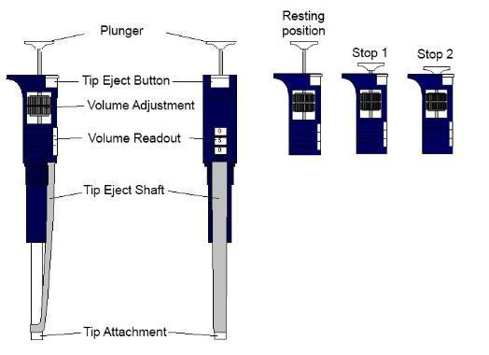
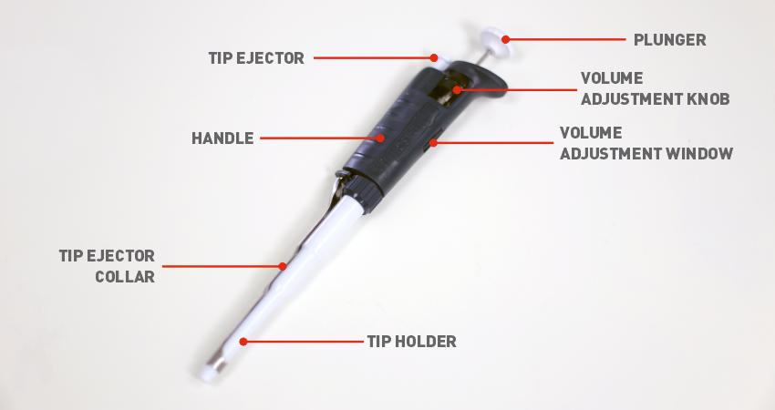
A typical pipette consists of:
Glass Pipette
- Graduated tube
- Calibration markings
- Tip
- Upper opening for pipette filler
Micropipette
- Plunger
- Volume adjustment dial
- Volume display
- Tip ejector
- Shaft
- Disposable pipette tip

Types of Pipettes

1. Volumetric Pipette
# Source: AI Source: Provided by: [Data Path: Persons Table -> ID Column: 1, Name_En Column: Motasem Essam] -> From: [ChatGPT] on [7/17/2026]
Description
Designed to deliver one fixed, highly accurate volume.
Features
- Bulb-shaped center
- Single calibration mark
- Highest accuracy among glass pipettes
Applications
- Analytical chemistry
- Standard solution preparation
- Calibration work

2. Graduated Pipette
# Source: AI Source: Provided by: [Data Path: Persons Table -> ID Column: 1, Name_En Column: Motasem Essam] -> From: [ChatGPT] on [7/17/2026]
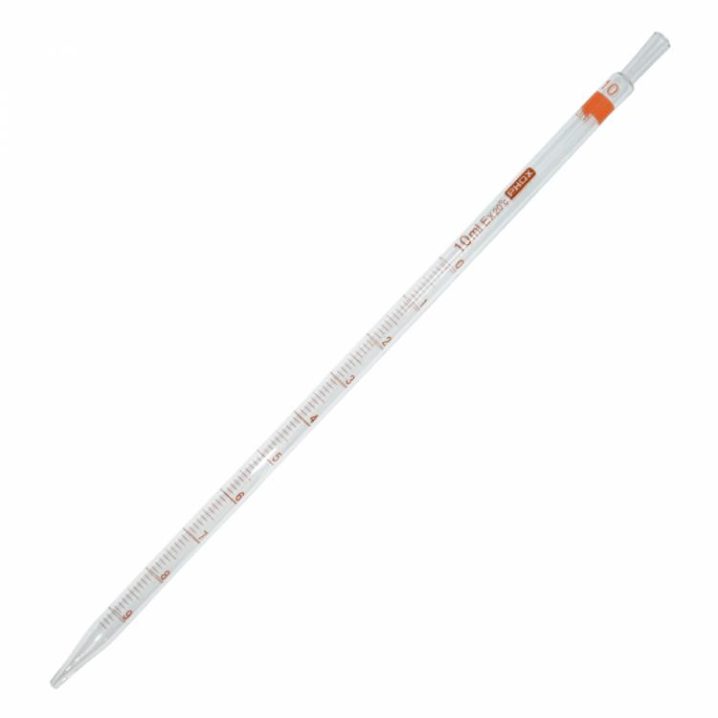

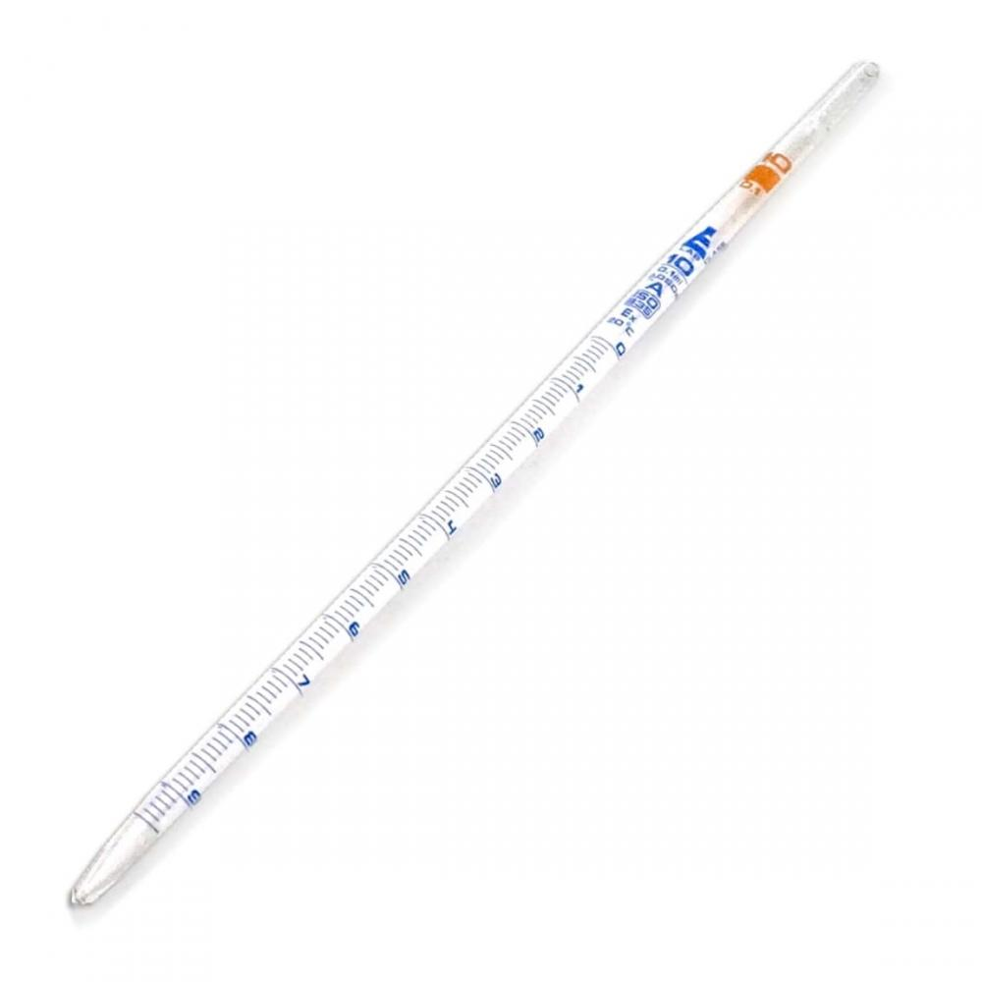
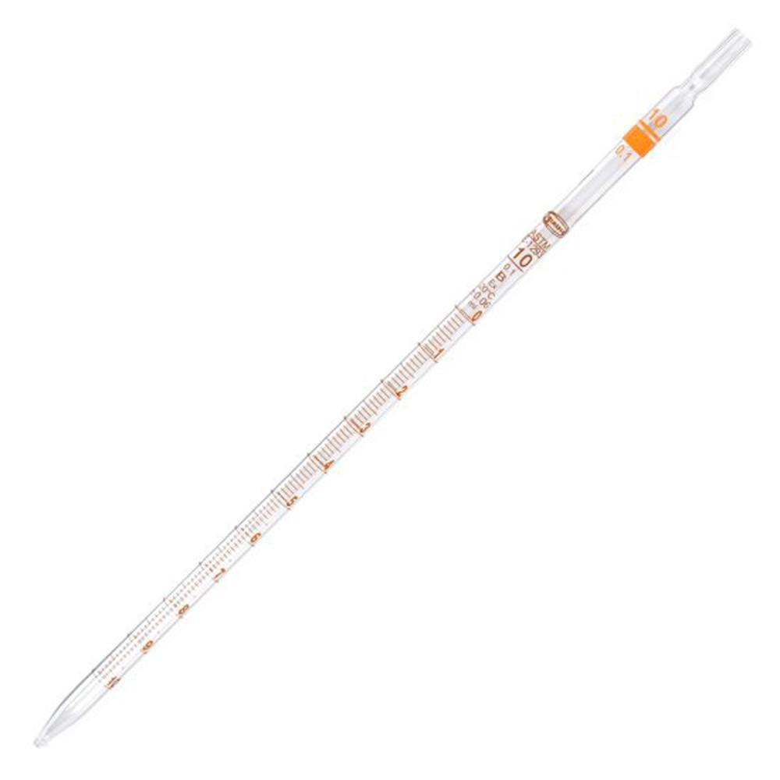
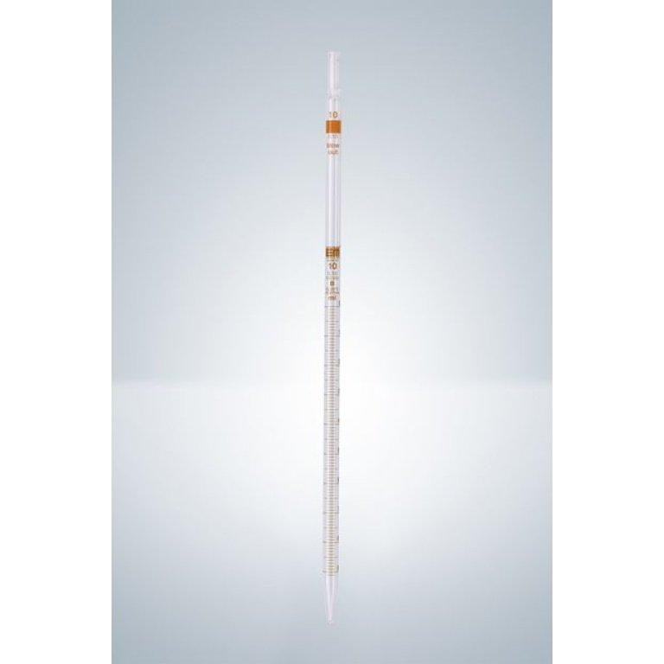
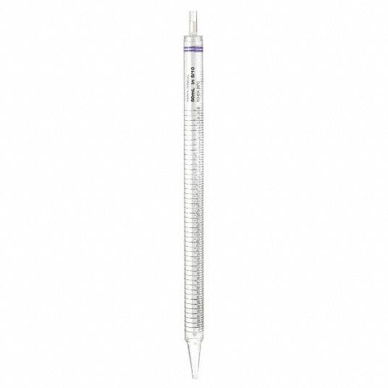
Description
Marked with multiple graduations to measure various liquid volumes.
Features
- Variable volume measurement
- Moderate precision
Applications
- General laboratory work
- Education
- Sample preparation

3. Serological Pipette
# Source: AI Source: Provided by: [Data Path: Persons Table -> ID Column: 1, Name_En Column: Motasem Essam] -> From: [ChatGPT] on [7/17/2026]
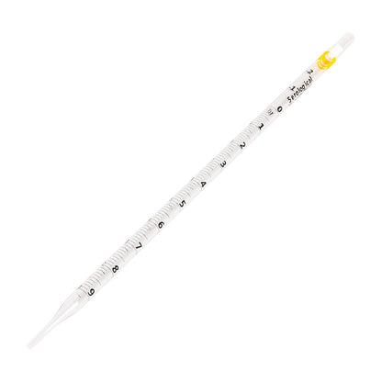
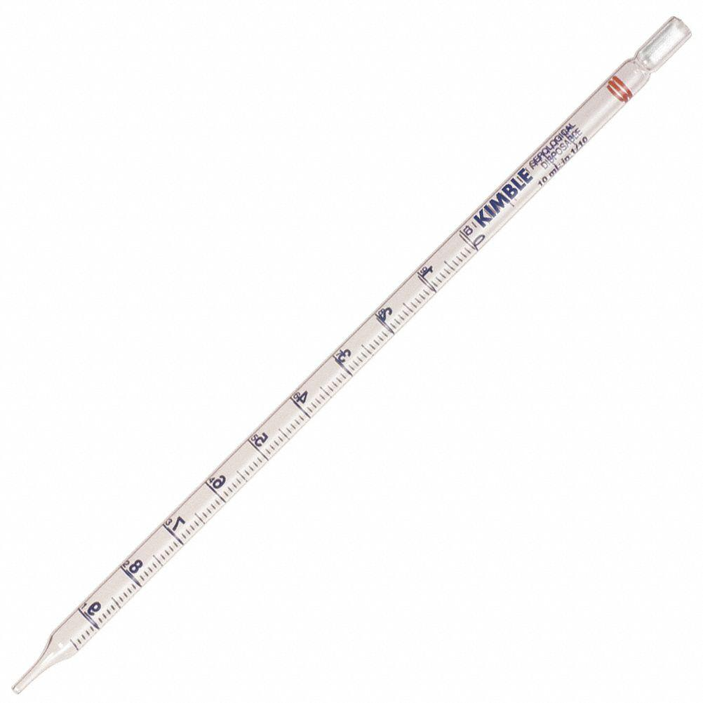
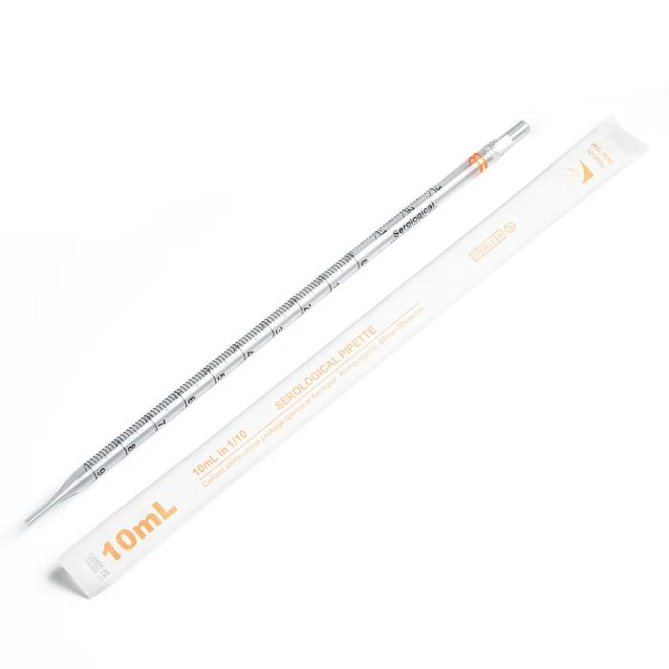
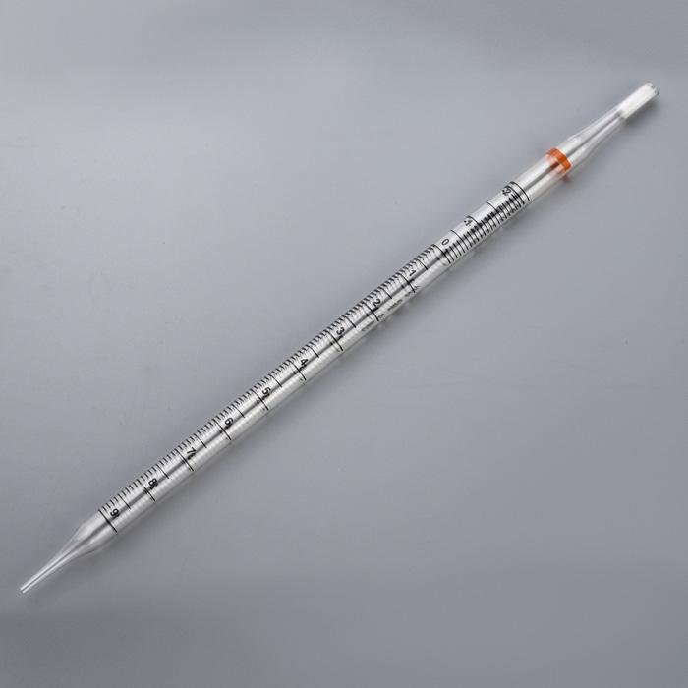
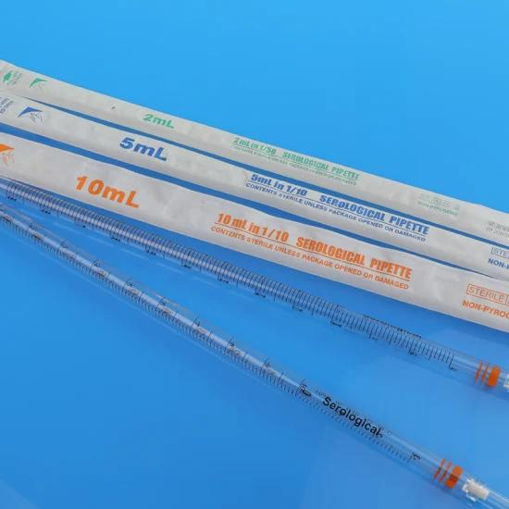
Description
A graduated pipette calibrated to deliver the full indicated volume.
Applications
- Cell culture
- Biology
- Medical laboratories

4. Micropipette
# Source: AI Source: Provided by: [Data Path: Persons Table -> ID Column: 1, Name_En Column: Motasem Essam] -> From: [ChatGPT] on [7/17/2026]

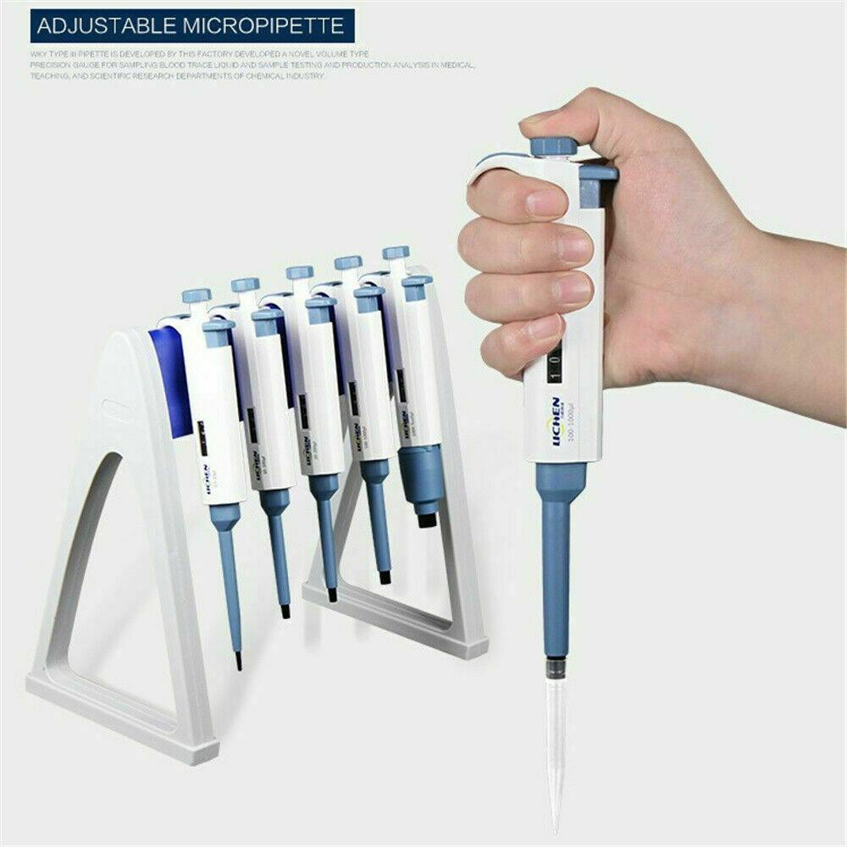
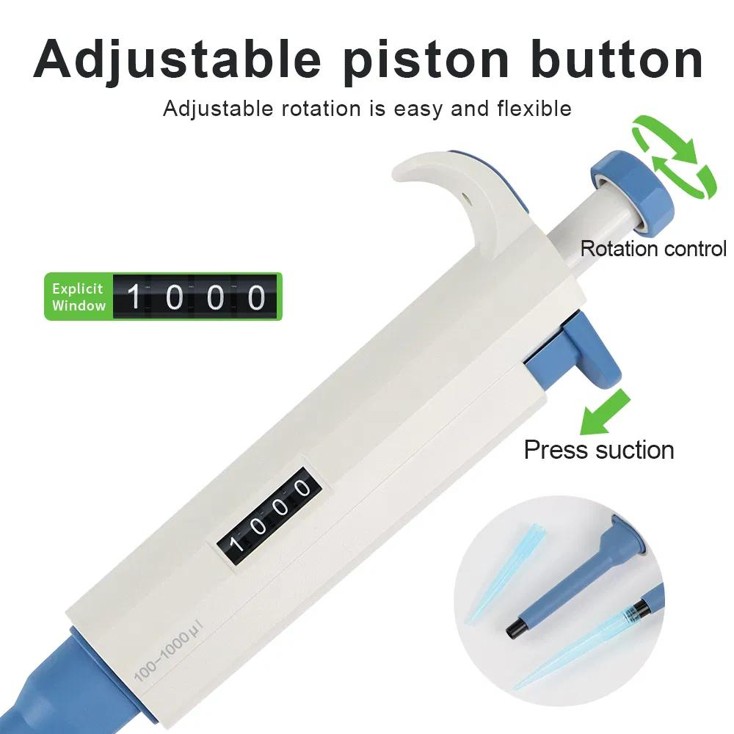
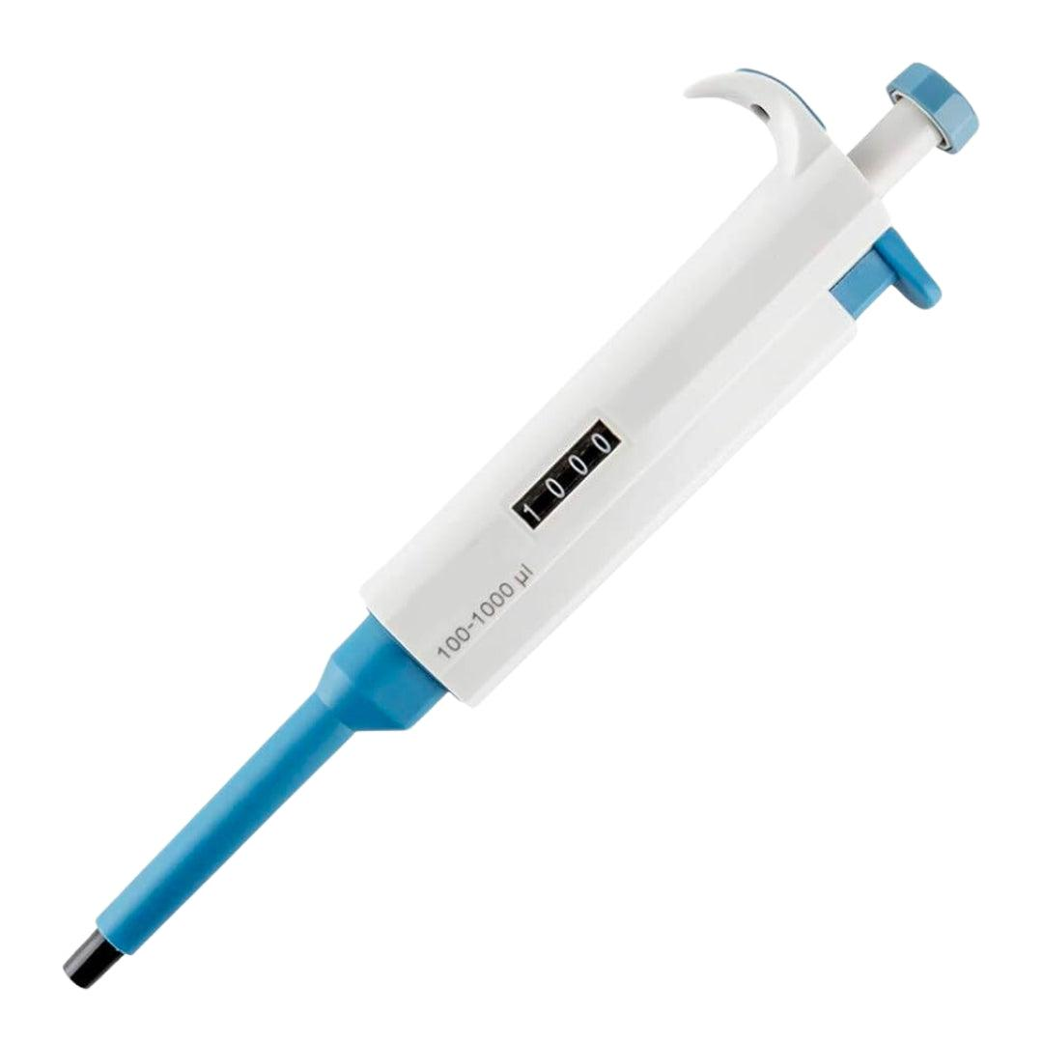
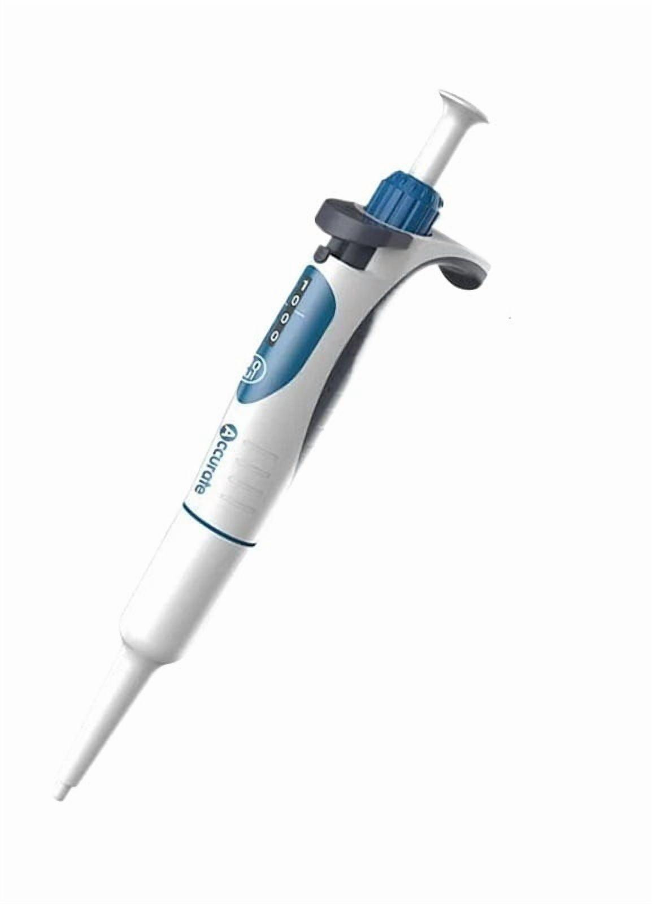
Description
An adjustable precision instrument for measuring microliter (µL) volumes.
Features
- Adjustable volume
- Disposable tips
- Very high precision
Applications
- Molecular biology
- PCR
- DNA analysis
- Biochemistry
- Clinical laboratories

5. Transfer Pipette (Disposable Pipette)
# Source: AI Source: Provided by: [Data Path: Persons Table -> ID Column: 1, Name_En Column: Motasem Essam] -> From: [ChatGPT] on [7/17/2026]
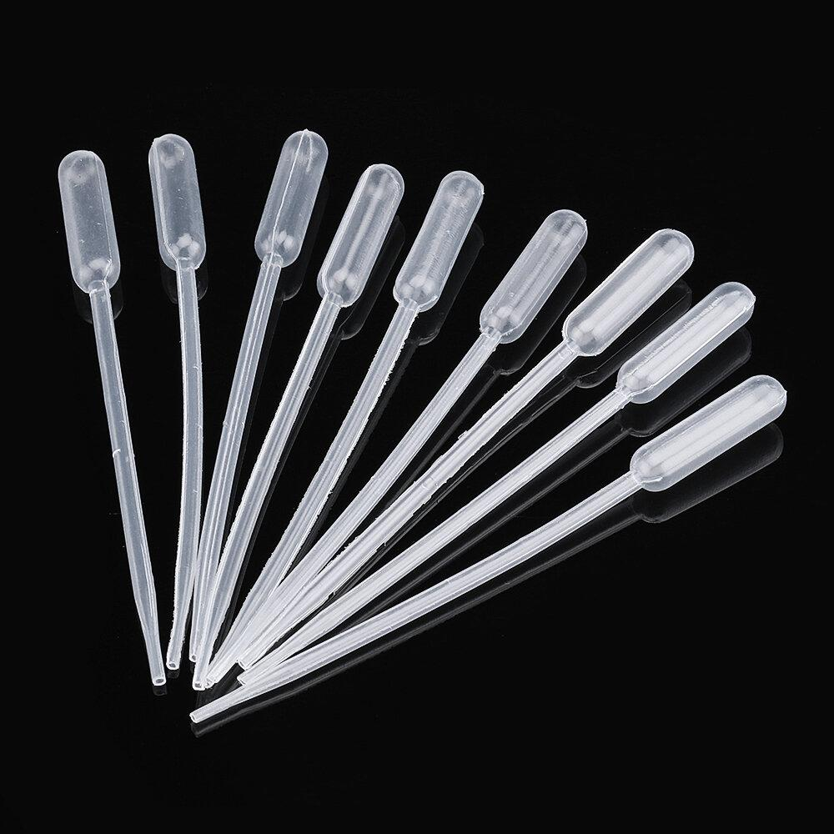
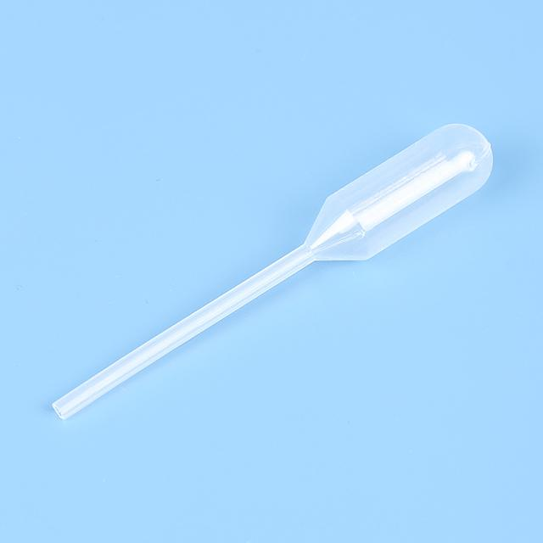
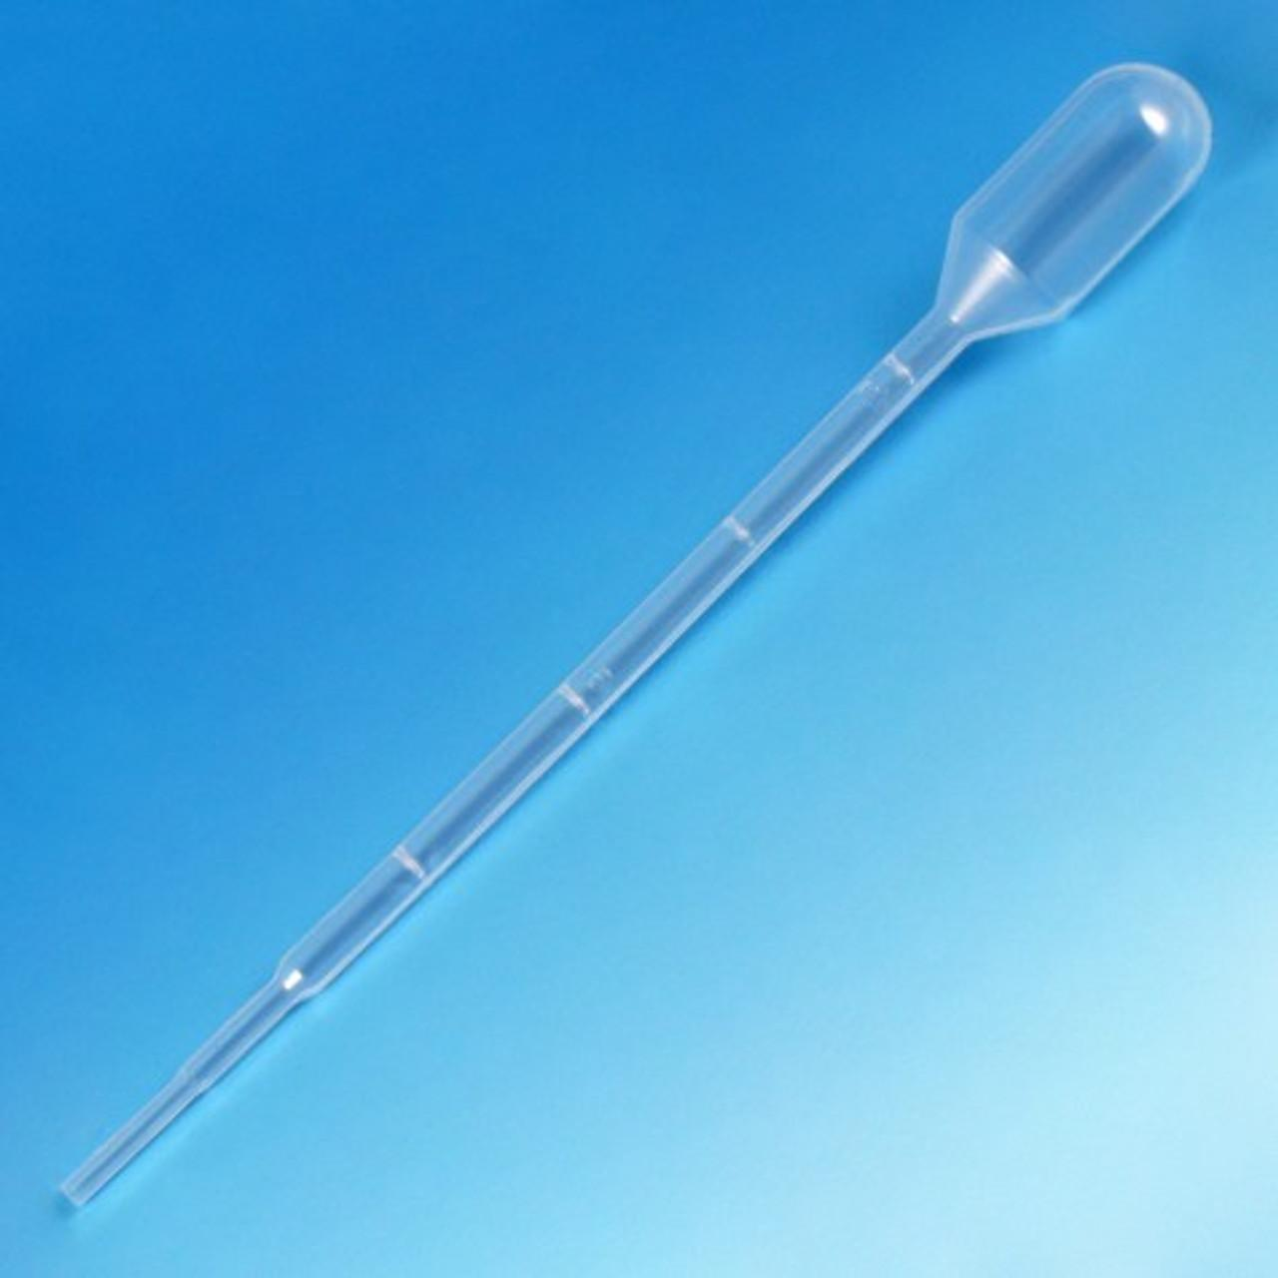
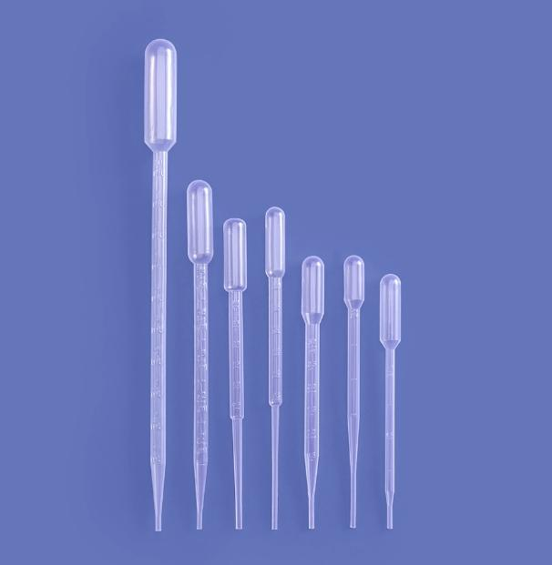
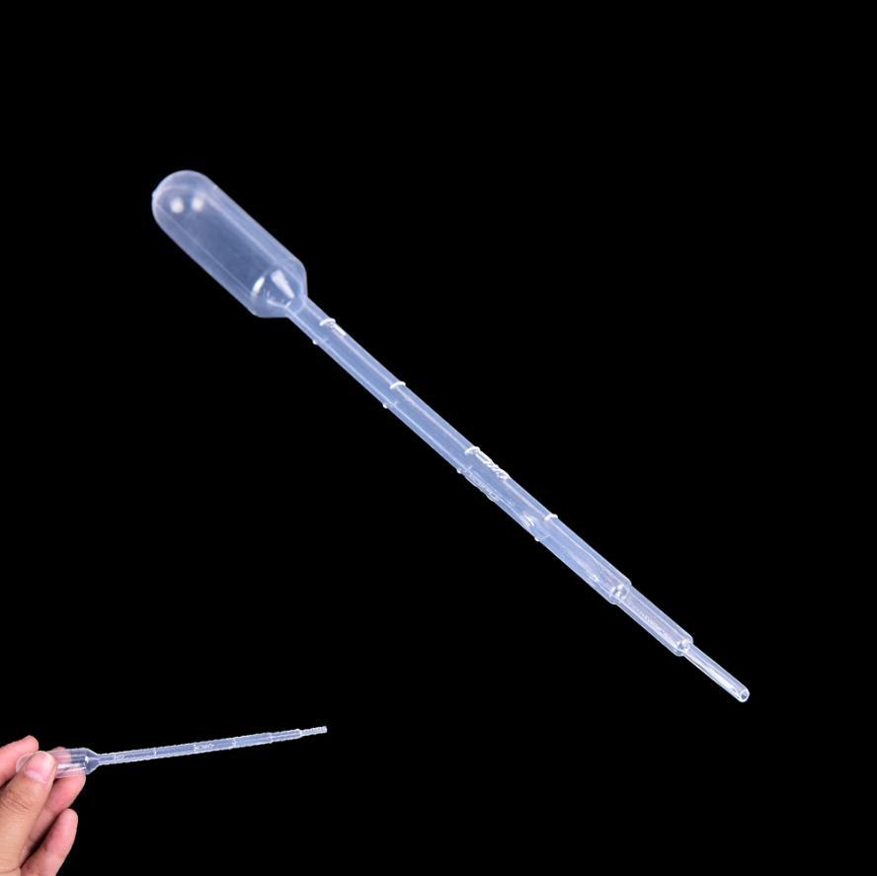
Description
Simple plastic pipette used for transferring liquids without high precision.
Applications
- Education
- General laboratory work
- Sample transfer

Measuring Units
# Source: AI Source: Provided by: [Data Path: Persons Table -> ID Column: 1, Name_En Column: Motasem Essam] -> From: [ChatGPT] on [7/17/2026]
Pipettes measure:
Glass Pipettes
- Milliliters (mL)
Micropipettes
- Microliters (µL)
Conversion:
- 1 mL = 1000 µL

Common Measuring Ranges
# Source: AI Source: Provided by: [Data Path: Persons Table -> ID Column: 1, Name_En Column: Motasem Essam] -> From: [ChatGPT] on [7/17/2026]
Volumetric Pipettes
- 1 mL
- 2 mL
- 5 mL
- 10 mL
- 20 mL
- 25 mL
- 50 mL
Micropipettes
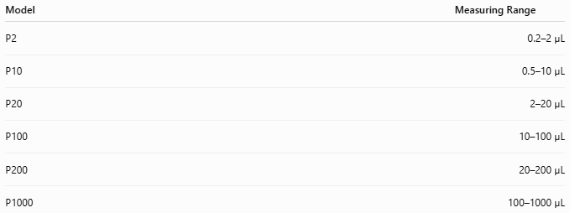
Model | Measuring Range
P2 | 0.2–2 µL
P10 | 0.5–10 µL
P20 | 2–20 µL
P100 | 10–100 µL
P200 | 20–200 µL
P1000 | 100–1000 µL

Resolution
# Source: AI Source: Provided by: [Data Path: Persons Table -> ID Column: 1, Name_En Column: Motasem Essam] -> From: [ChatGPT] on [7/17/2026]
Typical resolutions:
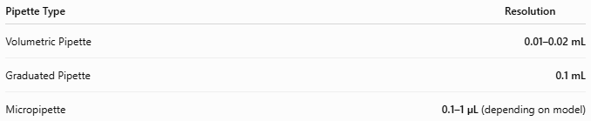
Pipette Type | Resolution
Volumetric Pipette | 0.01–0.02 mL
Graduated Pipette | 0.1 mL
Micropipette | 0.1–1 µL (depending on model)

Accuracy
# Source: AI Source: Provided by: [Data Path: Persons Table -> ID Column: 1, Name_En Column: Motasem Essam] -> From: [ChatGPT] on [7/17/2026]
Typical accuracy:
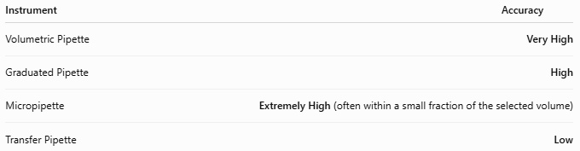
Instrument | Accuracy
Volumetric Pipette | Very High
Graduated Pipette | High
Micropipette | Extremely High (often within a small fraction of the selected volume)
Transfer Pipette | Low

How to Use a Glass Pipette
# Source: AI Source: Provided by: [Data Path: Persons Table -> ID Column: 1, Name_En Column: Motasem Essam] -> From: [ChatGPT] on [7/17/2026]
- Attach a pipette filler (never pipette by mouth).
- Draw liquid above the calibration mark.
- Adjust the liquid level to the calibration mark.
- Transfer the liquid to the receiving container.
- Allow the liquid to drain according to the pipette type.

How to Use a Micropipette
# Source: AI Source: Provided by: [Data Path: Persons Table -> ID Column: 1, Name_En Column: Motasem Essam] -> From: [ChatGPT] on [7/17/2026]
- Select the correct pipette range.
- Set the desired volume.
- Attach a clean disposable tip.
- Press the plunger to the first stop.
- Immerse the tip slightly below the liquid surface.
- Slowly release the plunger to aspirate the liquid.
- Dispense by pressing to the first stop, then to the second stop to expel any remaining liquid.
- Remove and discard the tip.

Example
# Source: AI Source: Provided by: [Data Path: Persons Table -> ID Column: 1, Name_En Column: Motasem Essam] -> From: [ChatGPT] on [7/17/2026]
A P200 micropipette is set to:
150 µL
It accurately transfers:
150 microliters

Sources of Error
# Source: AI Source: Provided by: [Data Path: Persons Table -> ID Column: 1, Name_En Column: Motasem Essam] -> From: [ChatGPT] on [7/17/2026]
Instrument Errors
- Calibration drift
- Damaged piston
- Worn seals
- Leaking tips

User Errors
- Incorrect plunger operation
- Holding the pipette horizontally while containing liquid
- Immersing the tip too deeply
- Air bubbles
- Wrong volume setting

Environmental Errors
- Temperature differences between pipette and liquid
- Evaporation
- Highly viscous liquids

Applications
# Source: AI Source: Provided by: [Data Path: Persons Table -> ID Column: 1, Name_En Column: Motasem Essam] -> From: [ChatGPT] on [7/17/2026]
Pipettes are used in:
- Chemistry laboratories
- Biology laboratories
- Medical diagnostics
- Pharmaceutical industries
- Biotechnology
- Microbiology
- PCR laboratories
- DNA sequencing
- Food testing
- Environmental analysis

Advantages
# Source: AI Source: Provided by: [Data Path: Persons Table -> ID Column: 1, Name_En Column: Motasem Essam] -> From: [ChatGPT] on [7/17/2026]
A pipette:
- Provides very high accuracy.
- Measures very small liquid volumes.
- Reduces contamination when using disposable tips.
- Is available in many volume ranges.
- Is essential for analytical laboratory work.

Limitations
# Source: AI Source: Provided by: [Data Path: Persons Table -> ID Column: 1, Name_En Column: Motasem Essam] -> From: [ChatGPT] on [7/17/2026]
A pipette:
- Requires regular calibration.
- Disposable tips increase operating cost.
- Incorrect technique reduces accuracy.
- Glass pipettes are fragile.
- Air-displacement micropipettes are less suitable for highly viscous or volatile liquids without special techniques.

Comparison with Other Volume Measuring Instruments
# Source: AI Source: Provided by: [Data Path: Persons Table -> ID Column: 1, Name_En Column: Motasem Essam] -> From: [ChatGPT] on [7/17/2026]
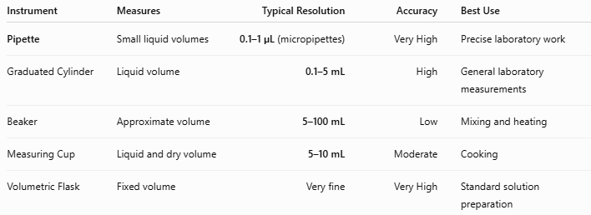
Instrument | Measures | Typical Resolution | Accuracy | Best Use
Pipette | Small liquid volumes | 0.1–1 µL (micropipettes) | Very High | Precise laboratory work
Graduated Cylinder | Liquid volume | 0.1–5 mL | High | General laboratory measurements
Beaker | Approximate volume | 5–100 mL | Low | Mixing and heating
Measuring Cup | Liquid and dry volume | 5–10 mL | Moderate | Cooking
Volumetric Flask | Fixed volume | Very fine | Very High | Standard solution preparation

Care and Maintenance
# Source: AI Source: Provided by: [Data Path: Persons Table -> ID Column: 1, Name_En Column: Motasem Essam] -> From: [ChatGPT] on [7/17/2026]
To maintain accuracy:
- Calibrate regularly.
- Store vertically on a pipette stand.
- Use the correct volume range.
- Replace worn seals and O-rings.
- Avoid dropping the pipette.
- Use clean disposable tips.
- Clean according to manufacturer instructions.

Common Mistakes
# Source: AI Source: Provided by: [Data Path: Persons Table -> ID Column: 1, Name_En Column: Motasem Essam] -> From: [ChatGPT] on [7/17/2026]
- Using the wrong pipette size.
- Pressing directly to the second stop before aspirating.
- Tilting the pipette while containing liquid.
- Reusing contaminated tips.
- Setting the volume outside the pipette's operating range.

Key Points
# Source: AI Source: Provided by: [Data Path: Persons Table -> ID Column: 1, Name_En Column: Motasem Essam] -> From: [ChatGPT] on [7/17/2026]
- A Pipette is a precision volume-measuring instrument.
- Common types:
  - Volumetric Pipette
  - Graduated Pipette
  - Serological Pipette
  - Micropipette
  - Transfer Pipette
- Measures:
  - mL
  - µL
- Micropipettes can measure fractions of a microliter with very high precision.
- Pipettes are indispensable in scientific, medical, pharmaceutical, and biological laboratories.

Conclusion
# Source: AI Source: Provided by: [Data Path: Persons Table -> ID Column: 1, Name_En Column: Motasem Essam] -> From: [ChatGPT] on [7/17/2026]
A Pipette is one of the most accurate and indispensable laboratory volume-measuring instruments, specifically designed for the precise measurement and transfer of small liquid volumes. Whether in the form of a volumetric pipette for fixed volumes or an adjustable micropipette capable of dispensing microliters, pipettes are essential for experiments where precision and repeatability are critical. Their widespread use in chemistry, biology, medicine, biotechnology, and pharmaceutical research makes them a cornerstone of modern laboratory practice.

